**MATLAB - 7**

**ANUSHA GARG**

**RA21110470232**

**QUESTION 1.** SOLVE : using given system of equations are:

X+2y-3z=-4

2x+3y+2z=2

3x-3y-4z=11.

1. INV

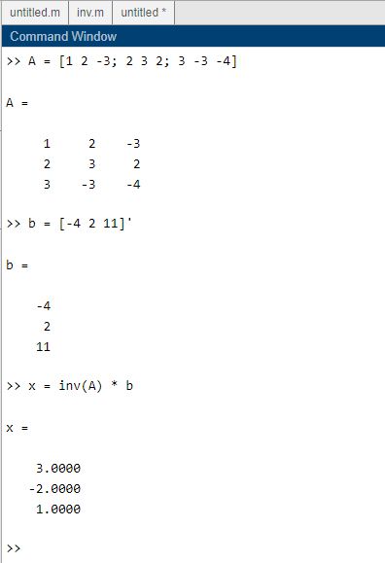

1. \

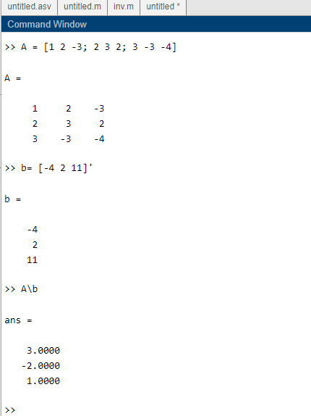

1. GAUSS ELIMINATION

